https://www.facebook.com/Ramongaliai/posts/1287309998343076
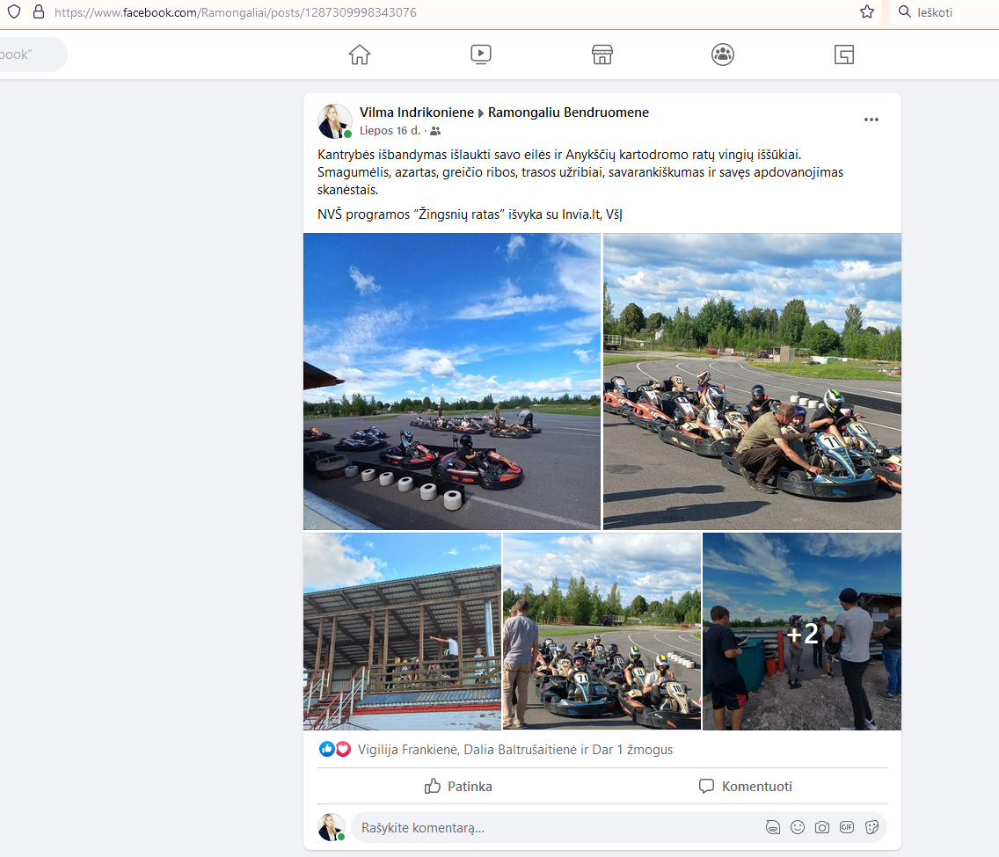

https://www.facebook.com/Ramongaliai/posts/1309079392832803
